COMPETITION
Create a
Feast for the Senses
with ingredients picked at the farm
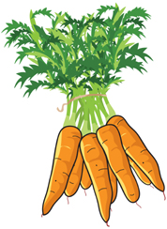

Create a salad using ingredients picked at the farm that will delight all of the senses.
Open to children under the age of 12
Judging at 3pm by Helen Browning, Chief Executive of the Soil Association
Prize – gardening equipment and seeds
How to Enter
The competition is open to all children under the age of 12.
Additional ingredients (e.g. for making a salad dressing) will be available on the day but you are also welcome to bring these along with you.
Please enter the competition at the desk between noon and 2pm. You will be accompanied to pick your ingredients. The completed salads will be judged at 3pm.
The judge’s decision is final.

